

Widgets

INSTALLATION GUIDE
for Openpay Price calculator Widgets Extension for Magento 1

Step 1 :
Go to your projects root folder & then upload files and folder to the root.

If you have any custom theme then upload theme files to the current theme (app/design/frontend/<Your package>/<Your Theme>).

Step 2 :
Then login to magento admin panel: SYSTEM -> Configuration -> OPENPAY WIDGET -> Widget Setup

1. Enable the module :

Expand 'Openpay Widgets Configuration' & set 'Yes' value against 'Enable Widgets' field.

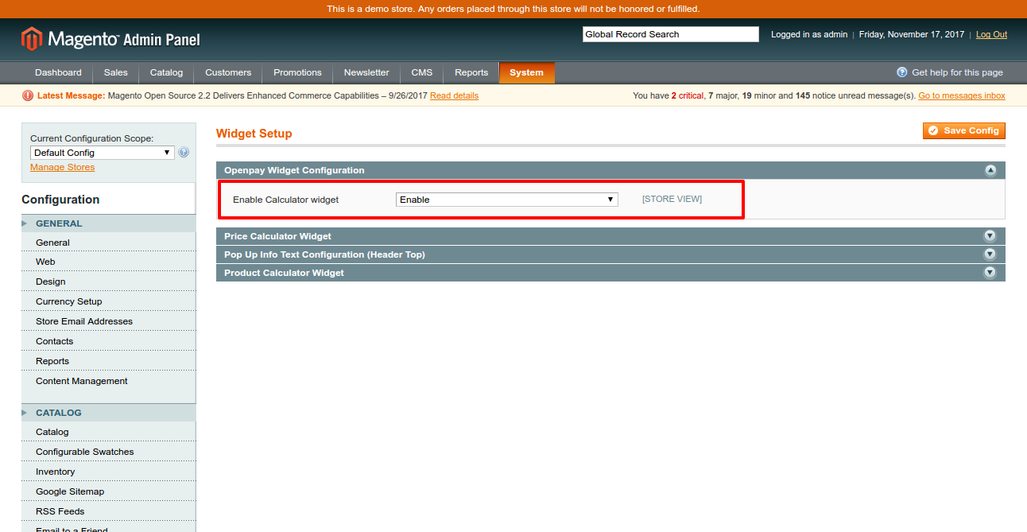

Click on 'Save Config'.

2. Set up 'Price calculator' widget :

Expand 'Price calculator widget' & fill out the fields as required.

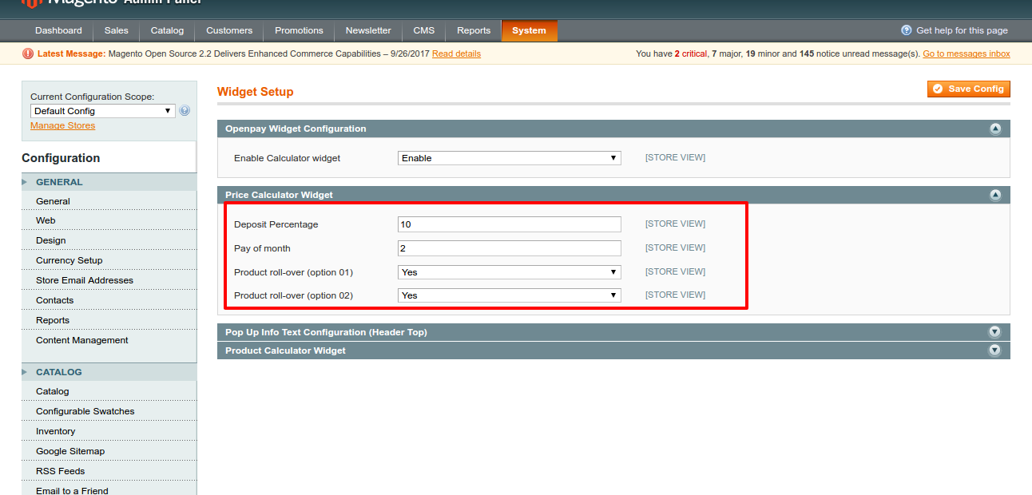

Deposit Percentage: Percentage amount
Pay of month: total number of months for full payment
Product roll-over (option 01): yes(mouse over widget on product image)
Product roll-over (option 02): yes(will be show static widget )
Click on 'Save Config'.

Frontend View :

'Price calculator' widget :

If module is enabled form admin , it will comes in list page of site.

Grid mode:-

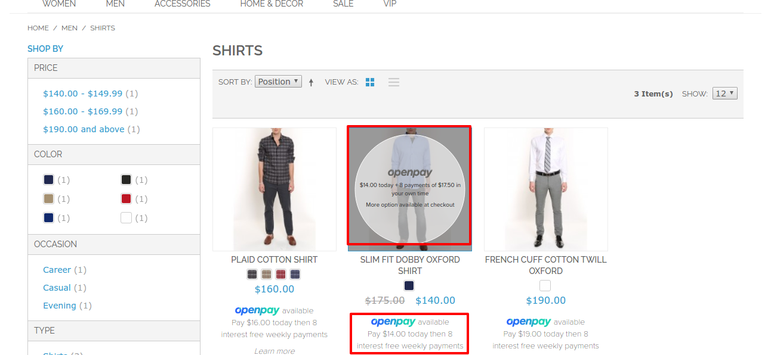

List mode:-

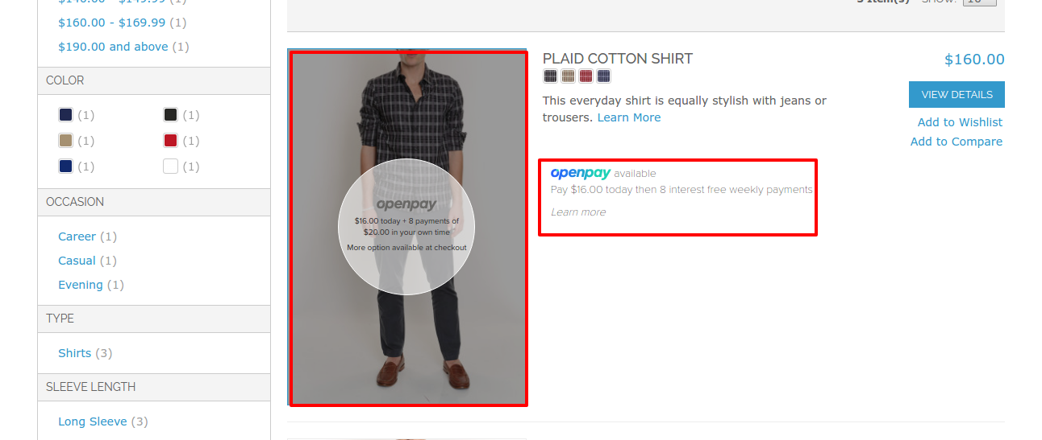

TO Display on List page , need to call two function in list.phtml file under your theme.
Your theme file will be like : (app/design/frontend/<Your package>/<Your Theme>/template/catalog/product/list.phtml).

For grid mode,

1. To display mouse over widget on product image add below lines..

<!-- Openpay Price Calculator -->
<?php
$openpayPriceCalculatorHelper = $this->helper('pricecalculatorwidget');
echo $openpayPriceCalculatorHelper->getOpenpayPriceCallculationRoundHtml($_product); ?>
<!-- End of openpay Price calculator -->

You have to call a function after end of product image tag .(<img/>)

2. To display static widget for each of product, add following code :
<!-- Openpay Price Calculator -->
<?php
$openpayPriceCalculatorHelper = $this->helper('pricecalculatorwidget');
echo $openpayPriceCalculatorHelper->getOpenpayPriceCallculationHtml($_product); ?>
<!-- End of openpay Price calculator -->

Need to add after “<?php echo $this->getPriceHtml($_product, true) ?>” line in grid mode.

For List mode,

1. To display mouse over widget add below lines..

<!-- Openpay Price Calculator -->
<?php
$openpayPriceCalculatorHelper = $this->helper('pricecalculatorwidget');
echo $openpayPriceCalculatorHelper->getOpenpayPriceCallculationRoundHtml($_product); ?>
<!-- End of openpay Price calculator -->

Add below lines after product image tag(<img />) same as grid mode.

2. To display static widget for each product, add bellow lines
<!-- Openpay Price Calculator -->
<?php
$openpayPriceCalculatorHelper = $this->helper('pricecalculatorwidget');
echo $openpayPriceCalculatorHelper->getOpenpayPriceCallculationHtml($_product); ?>
<!-- End of openpay Price calculator -->

Need to add end of div “desc std class ” which hold code of short description.

